Unit 2 (day 2) (till 95 slide)

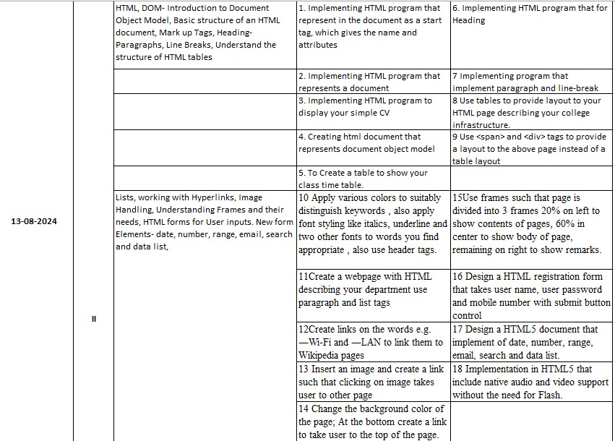

HTML, DOM- Introduction to Document Object Model,
Basic structure of an HTML document, Mark up Tags, Heading-Paragraphs, Line Breaks, Understand the structure of HTML tables. Lists, working with Hyperlinks, Image Handling, Understanding Frames and their needs,
HTML forms for User inputs. New form Elements- date, number, range, email, search and data list,

1st to 29 program from list
Programs unit 1
1. Implementing HTML program that represent in the document as a start tag, which gives the name and attributes
2. Implementing HTML program that represents a document
3. Implementing HTML program to display your simple CV
4. Creating html document that represents document object model
5. To Create a table to show your class time table.
6. Implementing HTML program that for Heading
7 Implementing program that implement paragraph and line-break
8 Use tables to provide layout to your HTML page describing your college infrastructure.
9 Use <span> and <div> tags to provide a layout to the above page instead of a table layout
10 Apply various colors to suitably distinguish keywords, also apply font styling like italics, underline and two other fonts to words you find appropriate, also use header tags.
11Create a webpage with HTML describing your department use paragraph and list tags
12Create links on the words e.g. ―Wi-Fi and ―LAN to link them to Wikipedia pages
13 Insert an image and create a link such that clicking on image takes user to other page
14 Change the background color of the page; At the bottom create a link to take user to the top of the page.
15Use frames such that page is divided into 3 frames 20% on left to show contents of pages, 60% in center to show body of page, remaining on right to show remarks.
16 Design a HTML registration form that takes user name, user password and mobile number with submit button control
17 Design a HTML5 document that implement of date, number, range, email, search and data list.
18 Implementation in HTML5 that include native audio and video support without the need for Flash.19 Creating HTML program to implement three articles with independent, self-contained content.

Page 53
CSS Border property Example:
<style>
table, th, td {
border: 2px solid black;
border-collapse: collapse;
}
</style>

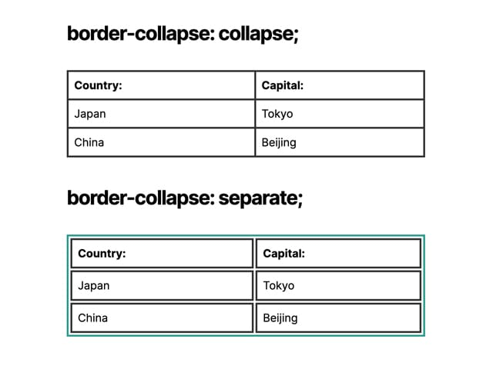

Explanation:
- Selector:
  - table, th, td: This part selects all <table>, <th>, and <td> elements in the HTML document. (th header, td cell in table)
- Declaration Block:
  - This block contains the styles to be applied to the selected elements.
- Properties and Values:
  - border: 2px solid black;: This sets a border for all selected elements with a width of 2 pixels, a solid style, and a black color.
  - border-collapse: collapse;: This property merges the borders of adjacent(side by side) table cells, creating a single, continuous border around the table.

HTML Table with cell padding (slide 55 )

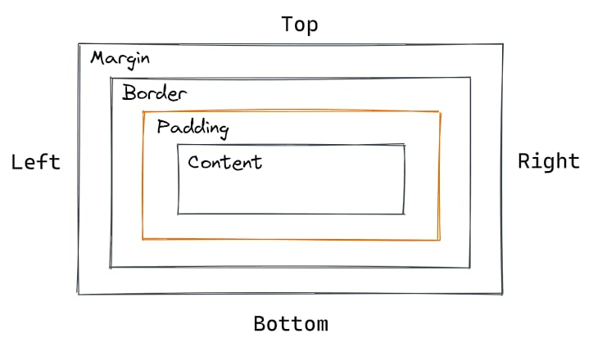

<style>
table, th, td {
border: 1px solid pink;
border-collapse: collapse;
}
th, td {
padding: 10px;
}

</style>

Note here ..padding: 10px;: Adds 10 pixels of padding around the content of each table header and table data cell.

Html example
<!DOCTYPE html>
<html>
<head>
<style>
table, th, td {
border: 1px solid pink;
border-collapse: collapse;
}
th, td {
padding: 10px;
}
</style>
</head>
<body>
<table>
<tr>
<th>Column 1</th>
<th>Column 2</th>
</tr>
<tr>
<td>Cell 1</td>
<td>Cell 2</td>
</tr>
</table>
</body>
</html>

Slide 58
Collspan, rowspan
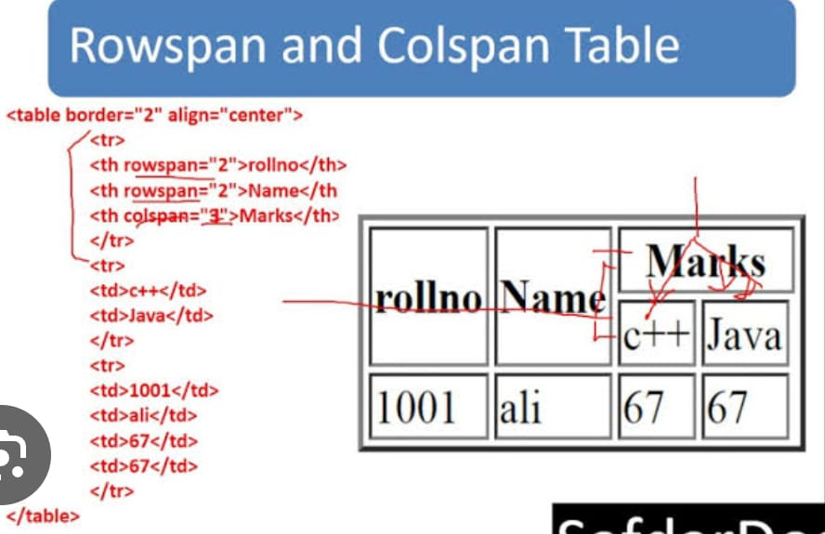
Explanation:
- <th>: This tag defines a header cell in an HTML table. Header cells are typically displayed in bold or a larger font than data cells (defined by <td> tags).
- colspan="3": This attribute tells the browser to make the header cell span across 3 columns. In other words, it will merge the next 3 columns into a single, wider header cell.
- Marks: This is the text content that will be displayed within the header cell.
Visual representation:
Imagine a table with 5 columns. The code <th colspan="3"> Marks </th> would create a header that spans the first three columns, leaving two columns for other headers.

PROGRAM 1

Implementing HTML program that represent in the document as a start tag, which gives the name and attributes.

<!DOCTYPE html>
<html>
<head>
<title>Start Tag Example</title>
</head>
<body>
<h1 id="main-heading" class="header">Hello, World!</h1>
<p>This is a simple example of an HTML start tag with attributes.</p>
</body>
</html>

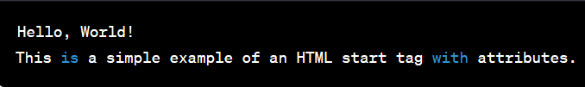

Explanation
Breakdown of the HTML Code
<!DOCTYPE html>
- This declaration specifies the document type as HTML5. It tells the browser how to interpret the code.
<html></html>
- This is the root element of an HTML document. All other elements must be descendants of this element.
<head></head>
- Contains meta-information about the document, which is not displayed on the page itself.
<title></title>
- Specifies the title of the document, which appears in the browser's title bar or tab.
<body></body>
- Contains the visible content of the document, which is displayed on the page.
<h1></h1>
- Defines a level-one heading. In this case, it displays the text "Hello, World!".
id="main-heading"
- This is an attribute of the <h1> element that assigns an ID named "main-heading" to the element. This ID can be used for styling or scripting purposes.
class="header"
- This is another attribute of the <h1> element that assigns a class named "header" to the element. This class can be used to apply styles to multiple elements with the same class.
<p></p>
- Defines a paragraph. In this case, it displays the text "This is a simple example of an HTML start tag with attributes."
Key Points:
- HTML elements are defined by start and end tags (e.g., <h1> and </h1>).
- Elements can have attributes (e.g., id and class) that provide additional information about the element.
- The head section contains meta-information about the document.
- The body section contains the visible content of the document.
This code will render a simple web page with the heading "Hello, World!" and a paragraph explaining start tags and attributes.

PROGRAM 2
Implementing HTML program that represents a document

<!DOCTYPE html>
<html>
<head>
<title>My First HTML Document</title>
</head>
<body>
<h1>Hello, World!</h1>
<p>This is my first HTML document.</p>
</body>
</html>

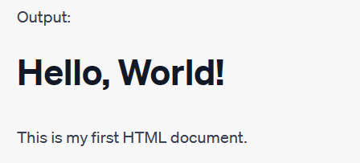

Explanation
Same as previous example
When you save this code as an .html file (for example, index.html) and open it in a web browser, you will see a page with the following content:
- A heading that says "Hello, World!"
- A paragraph that says "This is my first HTML document."
This is a basic HTML structure that demonstrates the fundamental elements of an HTML document.

PROGRAM 3
Implementing HTML program to display your simple CV

<!DOCTYPE html>
<html>
<head>
<title>My CV</title>
</head>
<body>
<div style="text-align: center;">
<h1>John Doe </h1>
<p>Web Developer</p>
</div>

<h2>About Me</h2>
<p>I am a passionate web developer with a strong foundation in HTML, CSS, and JavaScript. I love creating engaging and user-friendly websites that provide value to users.</p>

<h2>Experience</h2>
<h3>Front-end Developer - XYZ Tech (2019 - Present)</h3>
<p>At XYZ Tech, I've been responsible for developing responsive and interactive web interfaces. Collaborated with the design and backend teams to ensure seamless integration of features.</p>

<h3>Freelance Web Developer (2017 - 2019)</h3>
<p>Worked on various freelance projects, building websites for small businesses and individuals. Managed projects from concept to delivery, ensuring client satisfaction.</p>

<h2>Education</h2>
<h3>Bachelor's Degree in Computer Science - University of ABC (2015 - 2019)</h3>
<p>Studied computer science with a focus on web development. Took courses in algorithms, database management, and user experience design.</p>

<h2>Skills</h2>
<ul>
<li>HTML5, CSS3, JavaScript</li>
<li>Responsive Web Design</li>
<li>Front-end Frameworks (e.g., Bootstrap)</li>
<li>Version Control (Git)</li>
<li>Problem Solving and Algorithm Design</li>
</ul>

<h2>Contact</h2>
<p>Email: john@example.com</p>
<p>Phone: (123) 456-7890</p>
</body>
</html>



PROGRAM 4
Creating html document that represents document object model

<!DOCTYPE html>
<html>
<head>
<title>DOM Example</title>
</head>
<body>
<header>
<h1 id="main-heading">Welcome to My Website</h1>
</header>
<nav>
<ul>
<li><a href="#">Home</a></li>
<li><a href="#">About</a></li>
<li><a href="#">Services</a></li>
<li><a href="#">Contact</a></li>
</ul>
</nav>
<main>
<section id="about">
<h2>About Me</h2>
<p>I am a web developer with a passion for coding.</p>
</section>
<section id="services">
<h2>Services</h2>
<ul>
<li>Web Design</li>
<li>Front-end Development</li>
<li>Responsive Design</li>
</ul>
</section>
</main>
<footer>
<p>&copy; 2023 My Website. All rights reserved.</p>
</footer>
</body>
</html>

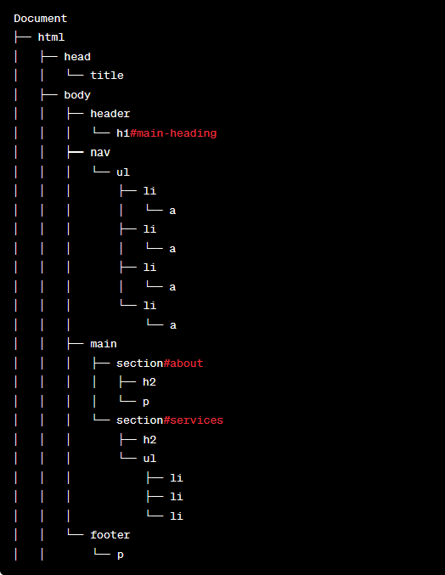
Output
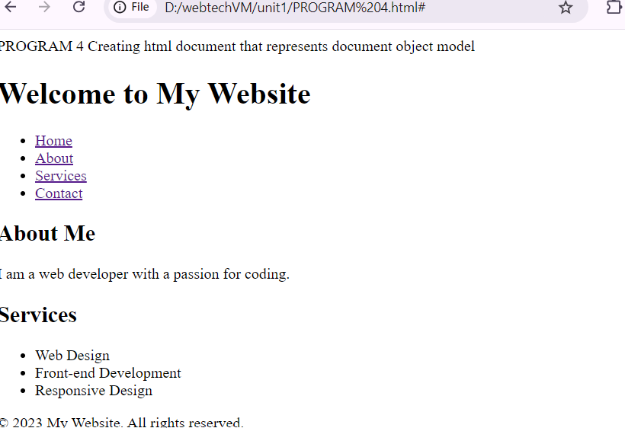

Explanation

Breaking Down the Code: <li><a href="#">Home</a></li>
Understanding the Components
This code snippet represents a single list item within an unordered list (usually defined by the <ul> tag).
- <li>: This tag defines a list item. It's used within <ul> and <ol> (ordered list) elements.
- <a>: This tag defines a hyperlink. It's used to create clickable links.
- href="#": This attribute specifies the link's destination. In this case, "#" is a placeholder for a specific URL or location. It's often used to create links that stay on the same page, or for links that haven't been defined yet.
- Home: This is the text displayed as the link content.
How it works together
When this code is rendered in a web browser, it will create a list item with a single link labeled "Home". Clicking on this link will typically do nothing, as the href="#" attribute doesn't specify a valid destination.

Why Use Semantic HTML Tags?
The primary reason for using HTML tags like <section>, <nav>, <main>, <header>, and <footer> is to improve the structure and semantics of your webpage. These tags are collectively known as
semantic HTML5 elements.
Benefits of Semantic HTML:
- Improved Search Engine Optimization (SEO): Search engines like Google understand the meaning of these tags. Using them correctly helps search engines understand your website's structure and content better, which can improve your search rankings.
- Enhanced Accessibility: Screen readers and other assistive technologies rely on semantic information to interpret web content. Using appropriate tags helps people with disabilities access and understand your website more easily.
- Better Code Readability and Maintainability: By using semantic elements, your HTML code becomes more organized and easier to understand. This makes it simpler to maintain and modify your website in the future.

- Responsive Design: Semantic HTML provides a solid foundation for creating responsive websites. These tags help define the different parts of a page, making it easier to adapt the layout to different screen sizes.

Understanding the Tags:
- <section>: Defines a thematic grouping of content, independent of the document's overall structure.
- <nav>: Identifies navigational links.
- <main>: Contains the main content of the page.
- <header>: Defines a header for a document or section.
- <footer>: Defines a footer for a document or section.

By using these tags correctly, you provide a clear structure for your web page, making it more accessible, understandable, and search engine friendly.

PROGRAM 5
To Create a table to show your class time table.

<!DOCTYPE html>
<meta charset="utf-8">
<meta name="viewport" content="width=device-width, initial-scale=1">
<html lang="en">

<head>
<title>HTML table</title>
</head>

<body>
<table border="1">
<tr>
<th>Day/Time</th>
<th>9-10</th>
<th>10-11</th>
<th>11-12</th>
<th>12-1</th>
<th>1-2</th>
<th>2-3</th>
<th>3-4</th>
<th>4-5</th>
</tr>
<tr>
<th rowspan="2">Monday</th>
<td>SE</td>
<td>Elective</td>
<td>CN</td>
<td>EITKL</td>
<th rowspan="10">Lunch</th>
<td>Elective</td>
<td>Elective</td>
<td>CN</td>
</tr>
<tr>
<td>XYZ</td>
<td>XYZ</td>
<td>XYZ</td>
<td>XYZ</td>

<td>XYZ</td>
<td>XYZ</td>
<td>XYZ</td>
</tr>
<tr>
<th rowspan="2">Tuesday</th>
<td colspan="2">Club Coding & Training</td>
<td colspan="2">Mini Project</td>

<td>SE Lab</td>
<td>DM</td>
<td>CN</td>
</tr>
<tr>
<td colspan="2">XYZ</td>
<td colspan="2">XYZ</td>

<td>XYZ</td>
<td>XYZ</td>
<td>XYZ</td>
</tr>
<tr>
<th rowspan="2">Wednesday</t>
<td>SE</td>
<td>DM</td>
<td>CN</td>
<td>Elective</td>

<td>Elective</td>
<td>SE</td>
<td>MOOCS</td>
</tr>
<tr>
<td>XYZ</td>
<td>XYZ</td>
<td>XYZ</td>
<td>XYZ</td>

<td>XYZ</td>
<td>XYZ</td>
<td>XYZ</td>
</tr>
<tr>
<th rowspan="2">Thursday</th>
<td>CN</td>
<td>MOOCs</td>
<td colspan="2">CN Lab</td>

<td>SE</td>
<td>DM</td>
<td>Elective</td>
</tr>
<tr>
<td>XYZ</td>
<td>XYZ</td>
<td colspan="2">XYZ</td>

<td>XYZ</td>
<td>XYZ</td>
<td>XYZ</td>
</tr>
<tr>
<th rowspan="2">Friday</th>
<td colspan="2">Competitive Coding</td>
<td>EITKL</td>
<td>SE</td>

<td>SE Lab</td>
<td>Elective</td>
<td>Elective</td>
</tr>
<tr>
<td colspan="2">XYZ</td>
<td>XYZ</td>
<td>XYZ</td>

<td>XYZ</td>
<td>XYZ</td>
<td>XYZ</td>
</tr>
</table>
</body>
</html>

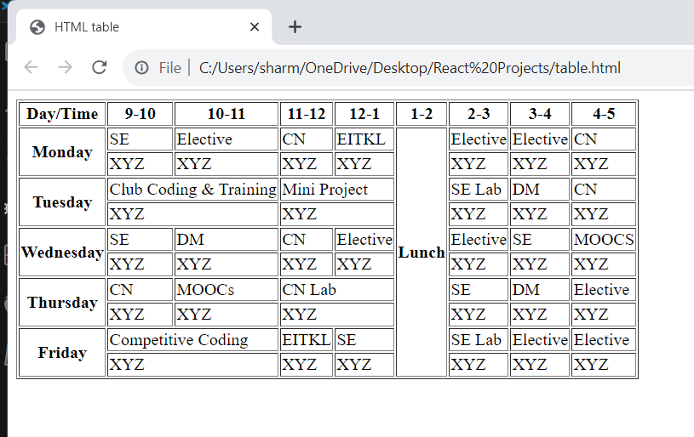

<!DOCTYPE html>
- This declaration specifies the document type to the browser. It tells the browser that the document is an HTML5 document. This is essential for correct rendering of the page.
<meta charset="utf-8">
- This meta tag defines the character encoding for the HTML document. UTF-8 is a character encoding capable of representing text in most of the world's writing systems. This ensures that characters are displayed correctly across different platforms and browsers.

<meta name="viewport" content="width=device-width, initial-scale=1">
- This meta tag is crucial for responsive web design. It controls the layout of the page on different screen sizes.
  - width=device-width: Sets the width of the viewport to match the width of the device's screen.
  - initial-scale=1: Sets the initial zoom level when the page is loaded. This prevents zooming in or out on mobile devices.

<html lang="en">
- This tag defines the root of an HTML document. The lang attribute specifies the language of the document content. In this case, the content is in English. This information is useful for screen readers and search engines.
In summary, these lines provide essential information about the HTML document, its character encoding, viewport settings, and language. They are typically placed at the beginning of the <head> section of an HTML document.

PROGRAM 10
Apply various colors to suitably distinguish keywords , also apply font styling like italics, underline and two other fonts to words you find appropriate , also use header tags.

<!DOCTYPE html>
<html lang="en">
<head>
<meta charset="UTF-8">
<meta name="viewport" content="width=device-width, initial-scale=1.0">
<title>College Infrastructure</title>
<style>
body {
font-family: Arial, sans-serif;
}
.container {
width: 80%;
margin: auto;
padding: 20px;
border: 1px solid #ddd;
}
.building {
margin-bottom: 20px;
}
.building h2 {
margin: 0;
padding-bottom: 5px;
border-bottom: 1px solid #ccc;
color: #3366cc;
}
.details {
margin-left: 20px;
color: #555;
}
.highlight {
color: #e74c3c;
font-style: italic;
text-decoration: underline;
}
.different-font {
font-family: 'Courier New', monospace;
}
</style>
</head>
<body>
<h1>College Infrastructure</h1>
<div class="container">
<div class="building">
<h2>Main Building</h2>
<div class="details">
<p><strong>Floors:</strong> <span class="highlight">5</span></p>
<p><strong>Rooms:</strong> <span class="highlight different-font">50</span></p>
<p><strong>Facilities:</strong> Lecture Halls, Offices</p>
</div>
</div>

<div class="building"> /*here we r calling .building selector fuctionalities by using same name class */

<h2>Library</h2>
<div class="details">
<p><strong>Floors:</strong> <span class="highlight">1</span></p>
<p><strong>Rooms:</strong> <span class="highlight">1</span></p>
<p><strong>Facilities:</strong> Study Area, <span class="different-font">Book Collection</span></p>
</div>
</div>

<div class="building">
<h2>Science Block</h2>
<div class="details">
<p><strong>Floors:</strong> <span class="highlight">3</span></p>
<p><strong>Rooms:</strong> <span class="highlight">20</span></p>
<p><strong>Facilities:</strong> Labs, Classrooms</p>
</div>
</div>

<div class="building">
<h2>Sports Complex</h2>
<div class="details">
<p><strong>Floors:</strong> <span class="highlight">1</span></p>
<p><strong>Rooms:</strong> <span class="highlight">1</span></p>
<p><strong>Facilities:</strong> Gym, Indoor Sports</p>
</div>
</div>
</div>
</body>
</html>

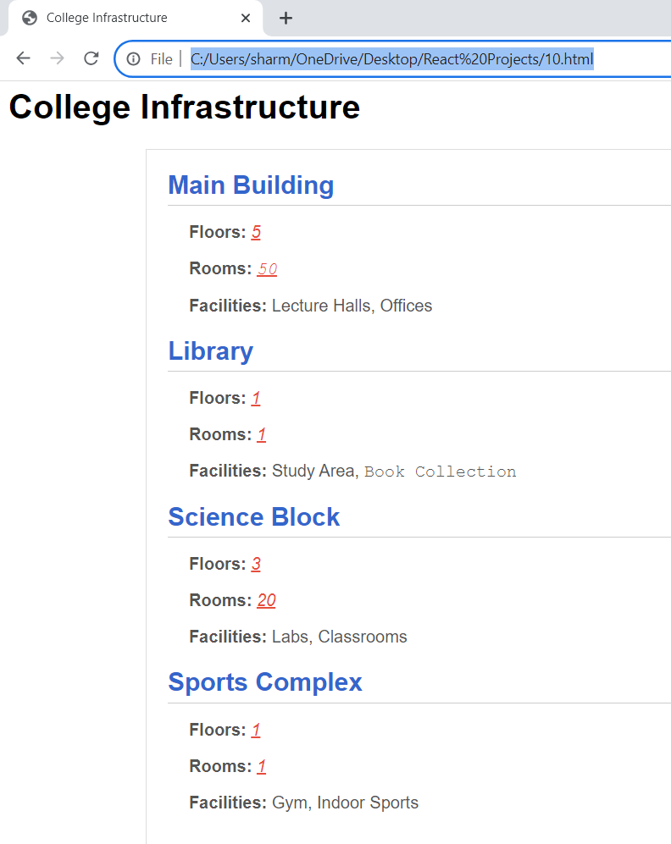

HTML Structure
This code creates a basic HTML structure to display information about a college's infrastructure. Let's break it down step by step:

1. Document Type Declaration:
HTML
<!DOCTYPE html>

This line declares the document type as HTML5, ensuring that browsers interpret the code correctly.

2. HTML Root:
HTML
<html lang="en">

This line defines the root of the HTML document and specifies the language as English.

3. Head Section:
HTML
<head>
</head>

The head section contains metadata about the document and styles for the page.
4. Meta Information:
HTML
<meta charset="UTF-8">
<meta name="viewport" content="width=device-width, initial-scale=1.0">

- meta charset="UTF-8": Specifies the character encoding for the document, allowing for international characters.
- meta name="viewport": Sets the viewport for mobile devices, ensuring proper scaling and responsiveness.

5. Title:
HTML
<title>College Infrastructure</title>

Sets the title of the webpage, which appears in the browser's tab or title bar.

6. Styles:
HTML
<style>
/* CSS styles */
</style>

This section contains CSS styles that define the appearance of the page elements.

7. Body Section:
HTML
<body>
</body>

The body section contains the visible content of the webpage.

HTML Content
HTML
<h1>College Infrastructure</h1>
<div class="container">
</div>

- <h1>College Infrastructure</h1>: Creates a main heading for the page.
- <div class="container"> creates a container to hold the building information.
Building Information
HTML
<div class="building">
<h2>Main Building</h2>
<div class="details">
</div>
</div>
Use code with caution.
This structure is repeated for each building, with the following elements:
- .building: Defines a container for each building.
- <h2>: Defines the building's name.
- .details: Contains specific information about the building, such as floors, rooms, and facilities.
CSS Styles
The CSS styles define the appearance of the page elements: (read about css selectors)
- body: Sets the default font family.
- .container: Sets the width, margin, padding, and border for the container.
- .building: Sets the margin-bottom for each building.
- .building h2: Styles the building headings.
- .details: Styles the details section within each building.
- .highlight: Styles highlighted text.
- .different-font: Sets a different font family for specific text.
Overall, the code creates a simple webpage that displays information about a college's infrastructure, including building names, details, and some styling.

Note
Understanding CSS Selectors: body, .details, .highlight
CSS Selectors
In CSS, selectors are used to target specific HTML elements to which styles will be applied. There are different types of selectors, and the dot notation you've observed is used for class selectors.
Class Selectors
A class is a named group of one or more HTML elements. You can apply styles to all elements with a particular class by using a dot (.) followed by the class name in your CSS.
Example:
CSS
.details {
margin-left: 20px;
color: #555;
}
Use code with caution.
This CSS rule will apply the styles margin-left: 20px; and color: #555; to any HTML element that has the class details.
Specific Selectors in Your Example
- body: This is a special selector that targets the <body> element of your HTML document. It's used to apply styles to the entire page content.
- .details: This is a class selector that targets elements with the class details. In your HTML, it's used to style the details section within each building.
- .highlight: This is another class selector that targets elements with the class highlight. It's used to style specific text within the details sections.
Why Use Classes?
- Reusability: You can apply the same styles to multiple elements by giving them the same class.
- Specificity: You can combine classes with other selectors to create more specific styles.
- Maintainability: It's easier to manage styles when they're grouped into classes.
In summary, the dot notation is used to define class selectors in CSS. It's a powerful tool for styling HTML elements efficiently and consistently.

PROGRAM 11
Create a webpage with HTML describing your department use paragraph and list tags

<!DOCTYPE html>
<html lang="en">
<head>
<meta charset="UTF-8">
<meta name="viewport" content="width=device-width, initial-scale=1.0">
<title>Department Overview</title>
<style>
body {
font-family: Arial, sans-serif;
margin: 20px;
}
h1 {
color: #333;
}
p {
margin-bottom: 15px;
}
</style>
</head>
<body>
<h1>Department of Computer Science</h1>
<p>Welcome to the Department of Computer Science at XYZ University! We are committed to providing a comprehensive education in the field of computer science.</p>

<h2>Our Mission</h2>
<p>Our mission is to empower students with a strong foundation in computer science theory and practical skills, preparing them for successful careers and lifelong learning.</p>

<h2>Programs Offered</h2>
<ul>
<li>Bachelor of Science in Computer Science</li>
<li>Master of Science in Computer Science</li>
<li>Ph.D. in Computer Science</li>
</ul>

<h2>Faculty</h2>
<p>Our dedicated faculty members are experts in their respective fields, contributing to research, industry collaborations, and the academic growth of our students.</p>

<h2>Research Areas</h2>
<ol>
<li>Artificial Intelligence and Machine Learning</li>
<li>Software Engineering</li>
<li>Data Science and Analytics</li>
<li>Computer Graphics and Visualization</li>
</ol>

<h2>Facilities</h2>
<p>Our department is equipped with state-of-the-art computer labs, research facilities, and a supportive learning environment to foster innovation and exploration.</p>

<h2>Get in Touch</h2>
<p>If you have any questions or would like to learn more about our programs, faculty, or research, feel free to contact us at <a href="mailto:info@csdepartment.xyz">info@csdepartment.xyz</a>.</p>
</body>
</html>

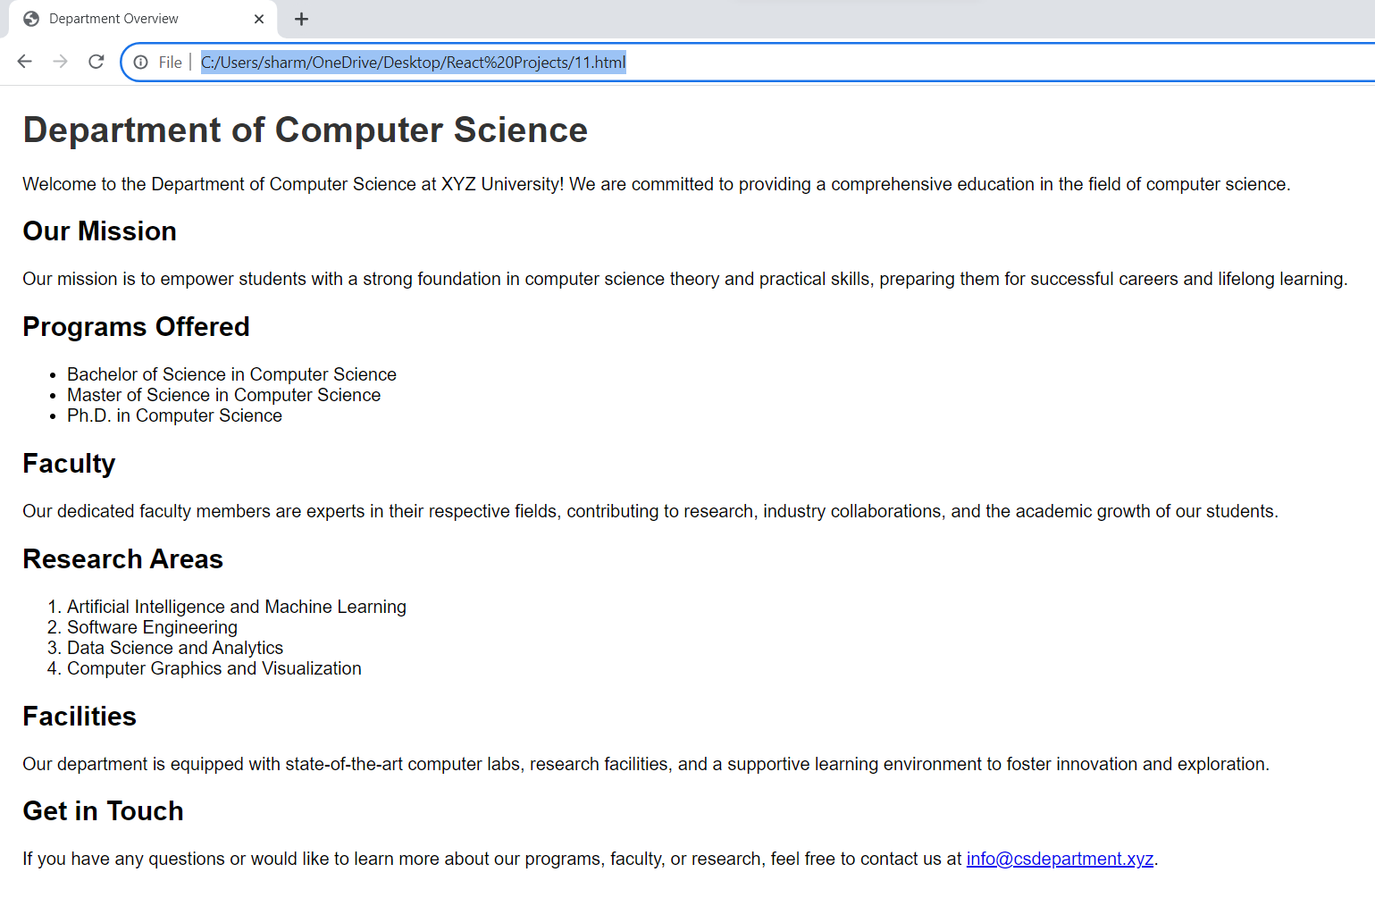

PROGRAM 12
Create links on the words e.g. ―Wi-Fi and ―LAN to link them to Wikipedia pages

<!DOCTYPE html>
<html>
<head>
<title>Link Example</title>
</head>
<body>
<p>
This is a sample text with links:
<a href="https://en.wikipedia.org/wiki/Wi-Fi">Wi-Fi</a> and
<a href="https://en.wikipedia.org/wiki/Local_area_network">LAN</a>.
</p>
</body>
</html>

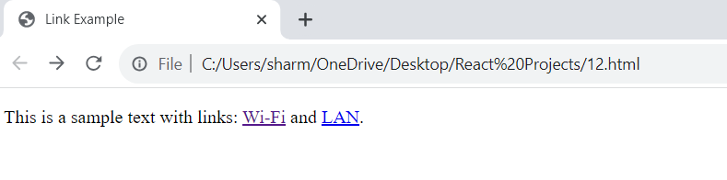

PROGRAM 13
Insert an image and create a link such that clicking on image takes user to other page

<!DOCTYPE html>
<html>
<head>
<title>Image Link Example</title>
</head>
<body>
<a href="https://www.example.com">
<img src="image.jpg" alt="Click me to go to another page">
</a>
</body>
</html>

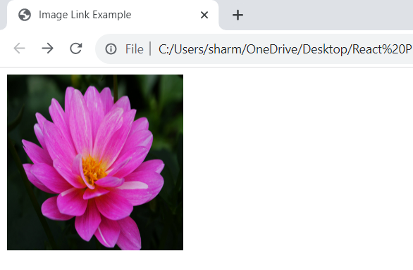
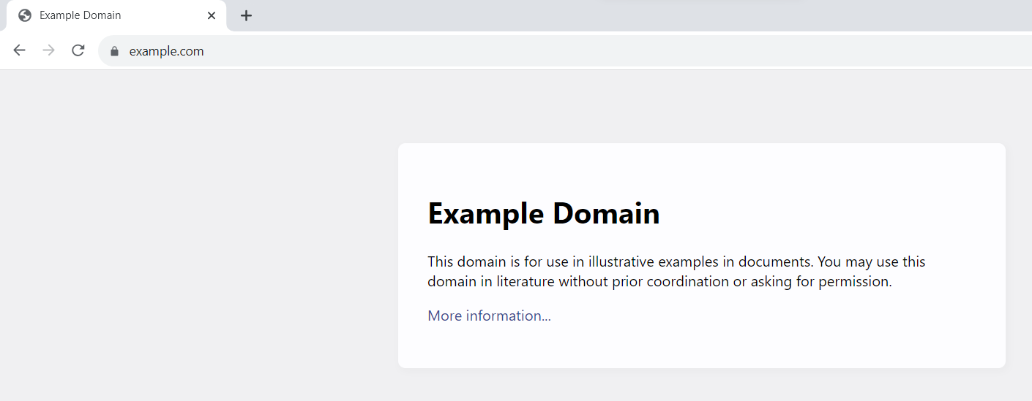

PROGRAM 14
Change the background color of the page; At the bottom create a link to take user to the top of the page.
<!DOCTYPE html>
<html>

<head>
<title>Background Color and Back to Top Example</title>
<style>
body {
background-color: #f2f2f2;
/* Set the background color */
margin: 0;
padding: 0;
font-family: Arial, sans-serif;
}

#backToTop {
position: fixed;
bottom: 20px;
right: 20px;
display: none;
}

#backToTop a {
background-color: #333;
color: white;
padding: 10px 15px;
text-decoration: none;
border-radius: 5px;
}

#backToTop a:hover {
background-color: #555;
}
</style>
<script>
window.onscroll = function() {
scrollFunction()
};

function scrollFunction() {
if (document.body.scrollTop > 20 || document.documentElement.scrollTop > 20) {
document.getElementById("backToTop").style.display = "block";
} else {
document.getElementById("backToTop").style.display = "none";
}
}

function scrollToTop() {
document.body.scrollTop = 0;
document.documentElement.scrollTop = 0;
}
</script>
</head>

<body>
<h1>Background Color and Back to Top Example</h1>
<p>This is a sample content on the page.</p>

<div id="backToTop">
<a href="javascript:void(0);" onclick="scrollToTop()">Back to Top</a>
</div>
</body>

</html>

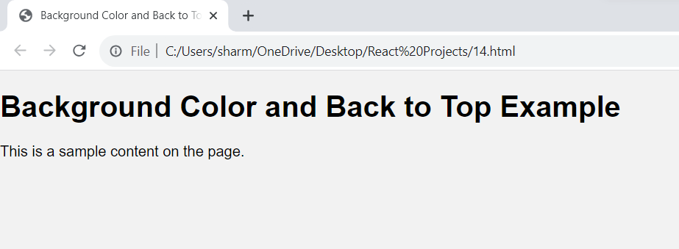

Note
CSS Styling
The CSS styles the page and the back-to-top link:
- body: Sets the background color to #f2f2f2, removes default margins and padding, and sets a font family.
- #backToTop: Positions the back-to-top link at the bottom right corner of the page and initially hides it.
- #backToTop a: Styles the link within the back-to-top div with background color, text color, padding, text decoration, and border radius.
- #backToTop a:hover: Styles the link when the mouse hovers over it.
JavaScript Functionality
The JavaScript code controls the visibility of the back-to-top link based on the user's scroll position:
- window.onscroll: Attaches a function to the scroll event.
- scrollFunction: Checks the scroll position and shows or hides the back-to-top link accordingly.
- scrollToTop: Scrolls the page to the top when the back-to-top link is clicked.
Step-by-Step Breakdown
- Set Background Color: The body CSS sets the background color to #f2f2f2.
- Create Back to Top Link: The HTML creates a div with the id backToTop and a link inside it.
- Style Back to Top Link: The CSS styles the link's appearance and position.
- Detect Scroll Position: The JavaScript function scrollFunction is called whenever the user scrolls.
- Show/Hide Back to Top Link: Based on the scroll position, the scrollFunction shows or hides the backToTop div.
- Scroll to Top: When the user clicks the back-to-top link, the scrollToTop function scrolls the page to the top.
In essence, the code creates a webpage with a light gray background and a back-to-top link that appears when the user scrolls down the page.

PROGRAM 15
Use frames such that page is divided into 3 frames 20% on left to show contents of pages, 60% in center to show body of page, remaining on right to show remarks.

<!DOCTYPE html>
<html>
<head>
<title>Frame Example</title>
</head>
<frameset cols="20%, 60%, *">
<frame name="contents" src="contents.html">
<frame name="body" src="body.html">
<frame name="remarks" src="remarks.html">
</frameset>
</html>

